Neon Retro Rave Sprout Hair Clips | Festival Hair Clips
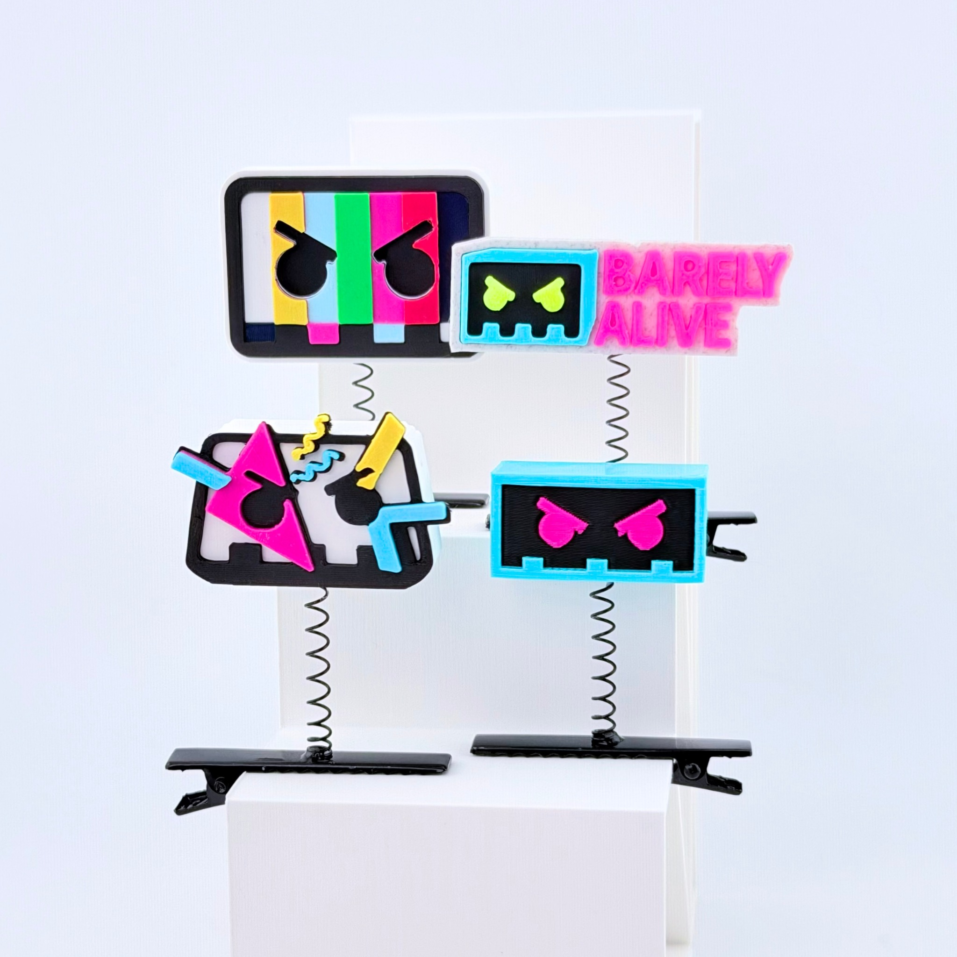
3D-printed PLA spring hair clips with metal alligator clips. Photo shows four design examples.

Keyword Strategy
Primary: rave sprout hair clips
Secondary: festival hair accessories, rave hair clips, neon rave accessories, EDM festival accessories, 3D printed hair clips
Keywords are relevance-based recommendations; search volumes were not independently verified.

Shopify
Product title: Neon Retro Rave Sprout Hair Clips | Festival Hair Clips
Bring a burst of neon energy to your next rave with these arcade-inspired Rave Sprouts! Featuring bold colors, pixel-inspired graphics, and playful geometric designs, these lightweight 3D-printed accessories add personality to your festival look. Each Rave Sprout features a metal spring alligator hair clip, making it easy to accessorize your hair, hat, or festival outfit. The built-in Sprocket spring pocket helps keep the charm attached to its spring. Whether you’re styling your next EDM event, coordinating with your rave crew, or looking for a fun festival gift, these colorful sprouts are ready to join the lineup.
- Neon Arcade Designs: Colorful pixel-inspired graphics with bold geometric details.
- Lightweight PLA: 3D-printed accessories for festival styling.
- Sprocket Feature: Built-in spring pocket helps secure the charm.
- Individually Packaged: Each Rave Sprout comes packaged separately.
SEO page title: Neon Retro TV Rave Sprout Clips | Festival Hair Clips
Meta description: Shop neon retro arcade rave sprout hair clips. Lightweight 3D-printed festival accessories with colorful pixel-inspired designs.

Etsy
Product title: Neon Arcade Rave Sprout Hair Clips, 3D Printed Festival Hair Accessories, Colorful EDM Hat Clips, Rave Trinkets & Gifts
Level up your festival accessories with these colorful, arcade-inspired Rave Sprouts! Featuring vibrant neon colors, retro pixel-style graphics, and bold geometric details, these 3D-printed hair clips bring playful energy to your rave outfit. Each lightweight PLA charm sits on a spring attached to a metal alligator clip. Perfect for accessorizing festival hairstyles, hats, and rave looks. A fun addition to your festival gear or a gift for the EDM lover in your life
- Retro Arcade Aesthetic: Bright neon colors and pixel-inspired designs.
- Lightweight 3D Prints: Made from PLA plastic.
- Secure Spring Attachment: Built-in Sprocket pocket helps hold the charm in place.
- Individually Packaged: Each sprout is packaged separately.
13 Etsy tags: rave sprout, festival hair clips, edm accessories, 3d printed clips, neon hair clips, pixel art accessory, sprout clips, hat clip accessory, hair accessories, plur gifts, kandi, gifts for ravers, retro arcade
Recommended category: Accessories > Hair Accessories > Barrettes & Clips

TikTok Shop
Product title: Neon Arcade Rave Sprout Hair Clips, 3D Printed Festival Hair Accessories
Add a pop of neon to your next rave! These arcade-inspired Rave Sprout hair clips feature colorful pixel-style designs mounted on flexible springs with metal alligator clips. Lightweight, playful, and easy to style with festival outfits, hats, or hairstyles.
- Neon Arcade Designs: Bright colors and pixel-inspired details.
- Lightweight PLA: 3D-printed decorative charms.
- Metal Hair Clips: Spring alligator clips for easy attachment.
- Built-in Sprocket: Spring pocket helps secure each charm.
- Individually Packaged: Each sprout comes packaged separately.
Recommended category: Hair Accessories > Hair Clips (confirm in Seller Center)

